Q1. “A conservative is a man with two perfectly good legs who, however, has never learned how to walk forward”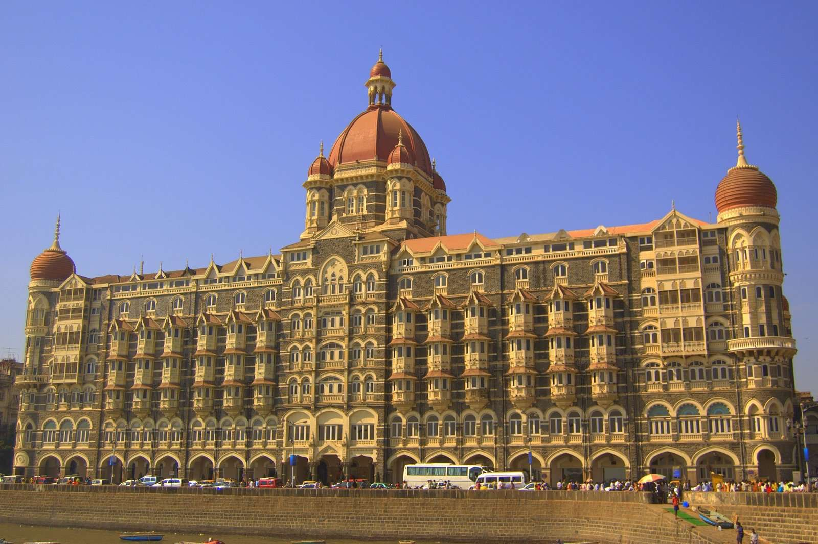

Hotel is your key.

Ans — Waldorf Astoria Hotel

Q2.“Let's go for a drive”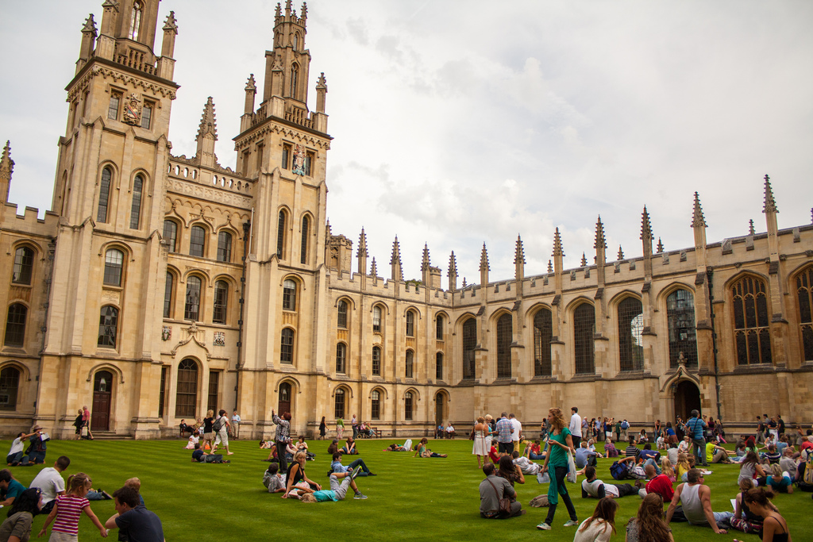

Ans — Zyxt

Q3. I rule the seas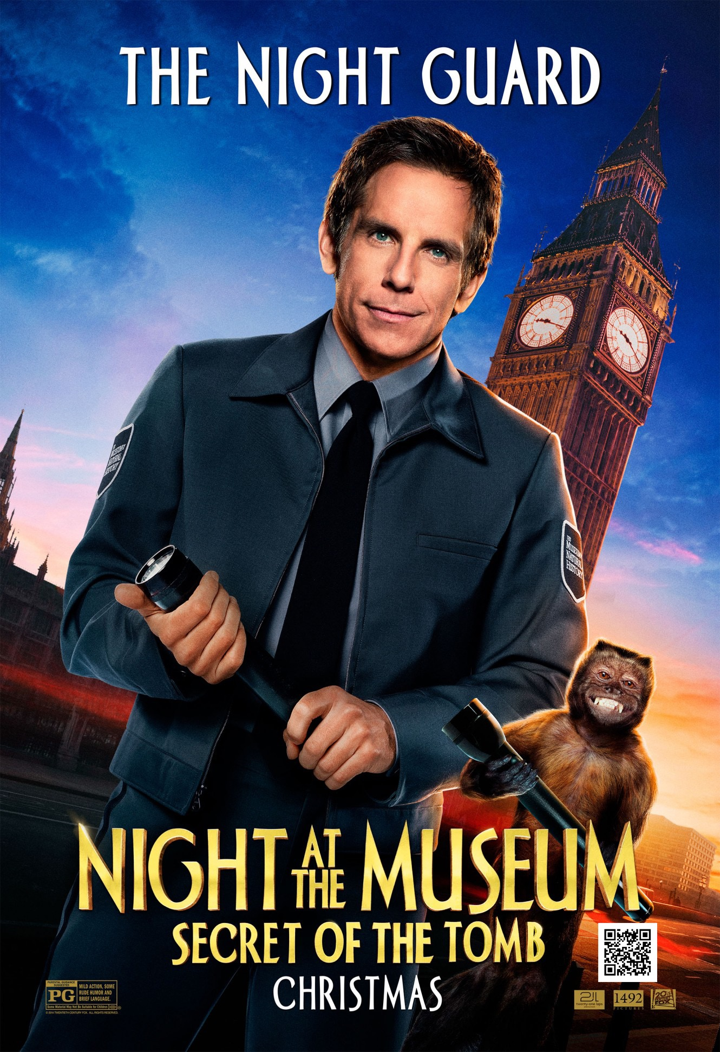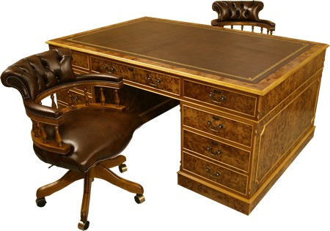

Ans — HMS Resolute

Q4. I am a cloud.

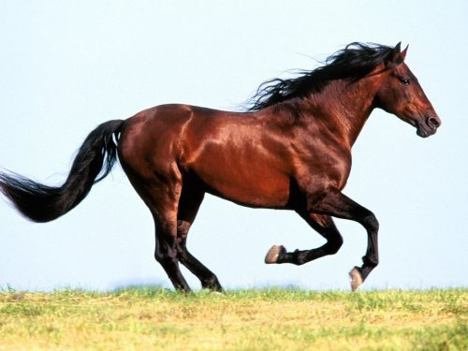

Ans — Horsehead Nebula

Q5. I am a Duck and I can give you anything on the net, but I won’t remember your wishes.

Q6. It is a very useful ratio in physics.



Ans — Poisson’s ratio

Q7.I am a band.

Ans- Sanam

Q8.

I am a house full of animals

Ans- Mark twain national forest

Q9. I am a hero of ancient past.



Ans- Hercules

Q10. I am a company.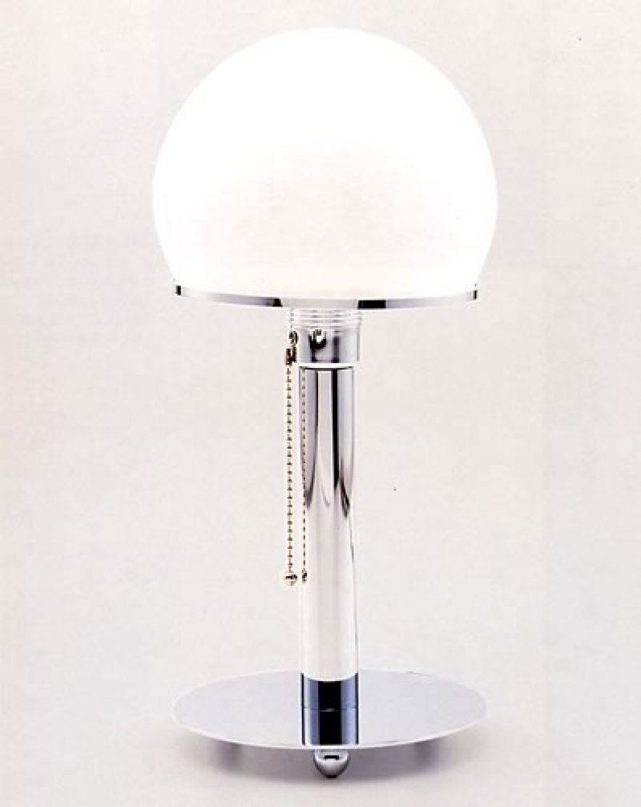

Ans- Pixar

Q11.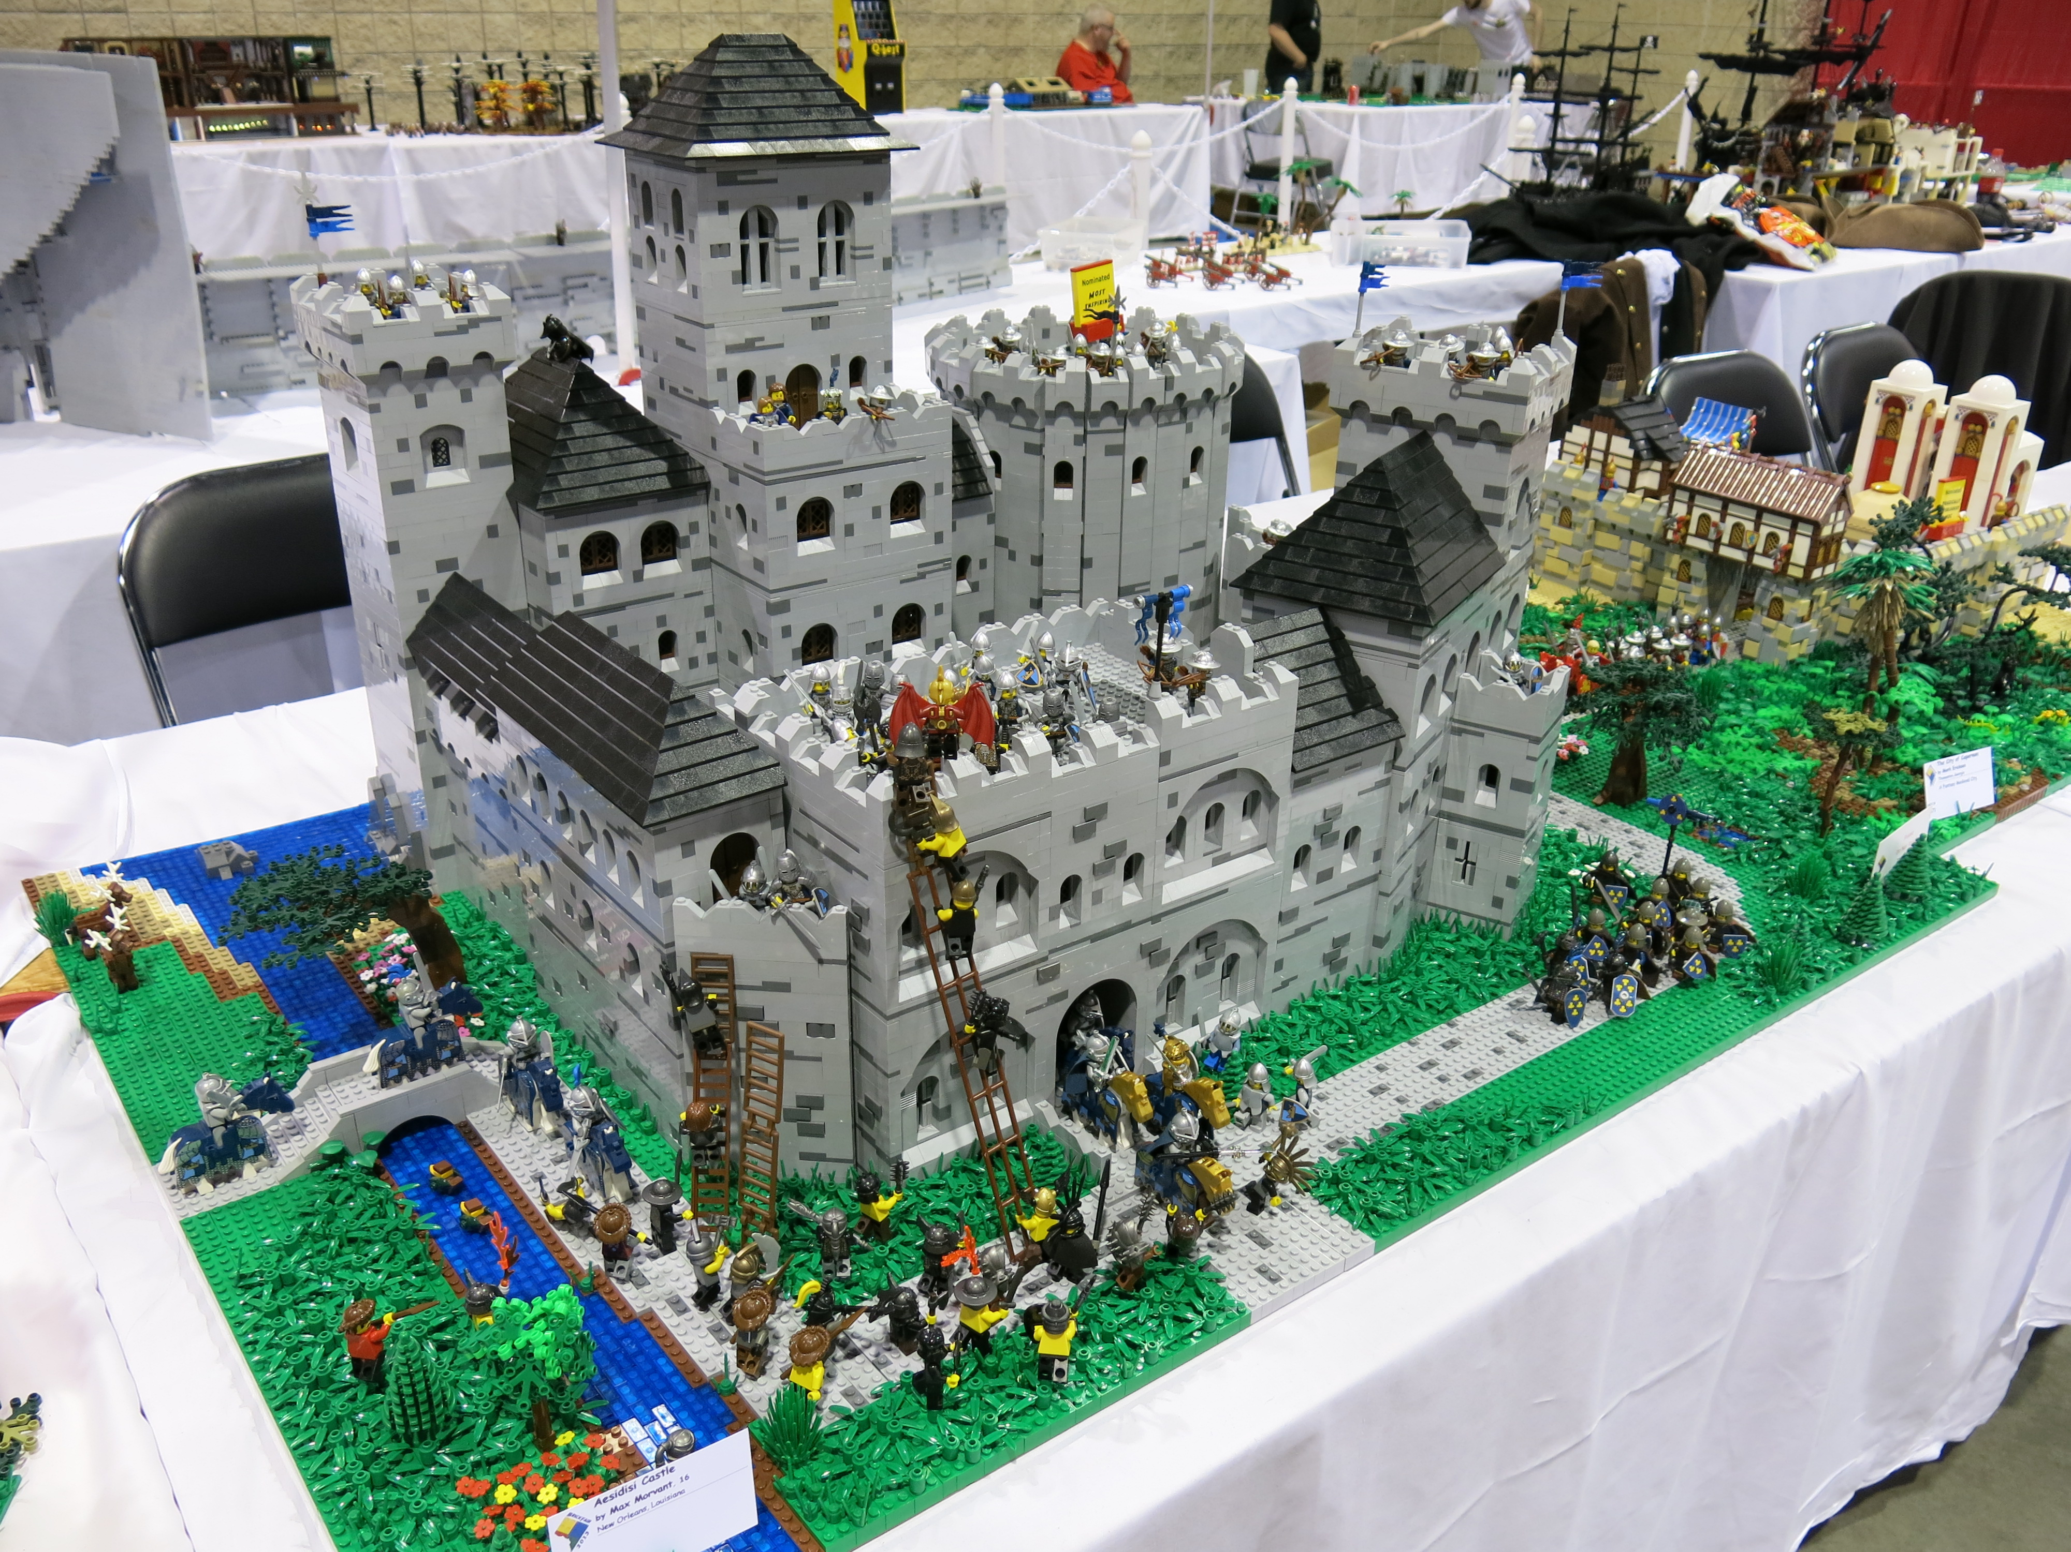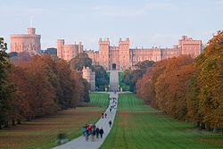 I am full of fun.

Ans - Legoland Windsor